Intro to SQL Server Assignment

### **Problem Statement:**

Consider yourself to be Sam, who is a student at a prestigious university. You have enrolled for the SQL course and it is your first semester.

## Tasks to be done:

1. Install MS SQL Server

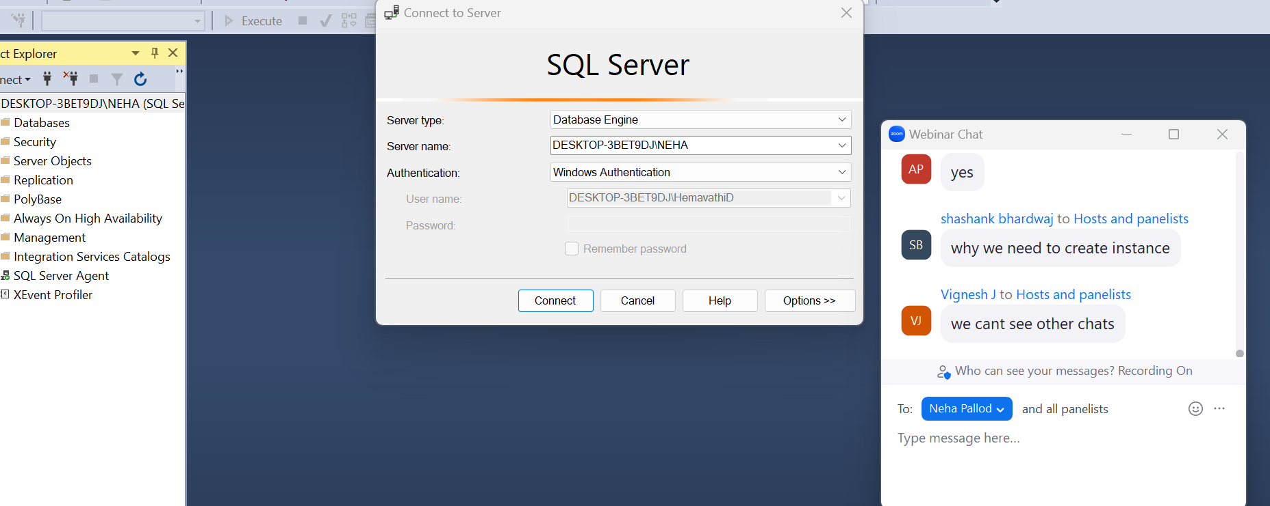

1. Learn the basics of Structured Query Language

SQL

DATA->RAW FACT THAT DESCRIBE PROPERTIES/ATTRIBUTE OF ENTITY

RAW FACT->CANT CHANGE

STUDENT NAME IS ANITHA

ATTRIBUTE ->PROPERTIES OF AN ENTITY

ENTITY /OBJECT-> ANYTHING IS PHYSICALLY EXISTS IS CALLED OBJECT/ENTITY

DATABASE->PLACE OR MEDIA WHERE WE CAN STORE THE DATA IN SYSTEMATIC AND

ORGANIZED WAY

CRUD->CREATE ,READ,UPDATE,DELETE

DATABASE MANAGEMENT SYSTEM->SOFTWARE WHICH MAINTAIN AND MANAGE THE DATABASE

MSSQL SOFTWARE

TWO IMP FEATURE

SECURITY

AUTHORIZATION

TYPES OF DBMS

4

NETWORK DBMS

OBJECT ORIENTED DBMS

HIERARCHICAL DBMS

RDBMS->RELATIONAL DATABASE MANAGEMENT SYSTEM( 99%)

RDBMS->ITS A TYPE OF DBMS SOFTWARE WHERE WE CAN STORE THE DATA IN THE FORM OF TABLES/RELATION

SQL LANGUAGES/ SQL STATEMENTS/ COMMANDS

DDL ->data definition language( CREATE,RENAME,ALTER,TRUNCATE,DROP )

DML -> data manipulation language(INSERT,DELETE ,UPDATE)

TCL ->TRANSACTION CONTROL LANGUAGE(COMMIT,ROLLBACK,SAVE POINT)

DCL ->DATA CONTROL LANGUAGE(GRANT,REVOKE)

DQL ->DATA QUERY LANGUAGE(SELECT)